Turing machine
An understanding of Finite state machines is required for this work.
A Turing machine is designed to find the first blank cell on the tape to the right of the current position of the read/write head.
It has 3 states S0, S1 and S2, where S0 is the start state and S2 is the stop state. The machine’s alphabet is 0, 1 and where represents a blank.
The finite state transition diagram representing the machine is shown below:
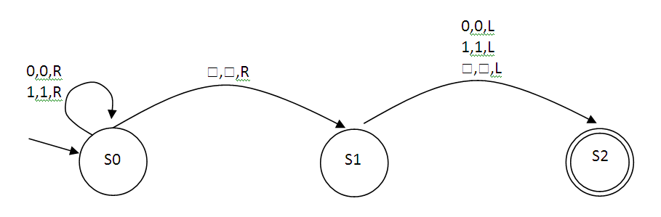
The notation (input, output, movement) is used in this diagram so that for example:
(0, 0, R) means “if the input is 0, write a 0 and move right”
(0, 2, L) means “If the input is 0, write a 1 and move left”
The string 110 is on the tape and the read-write head is positioned at the leftmost 1

... | 1 | 1 | 0 |  |  |  | ...
Read/Write head
S0

The computation of the Turing machine can be traced as follows:
... | 1 | 1 | 0 |  |  |  | ...
S0

S0

S0

... | 1 | 1 | 0 |  |  |  | ...
... | 1 | 1 | 0 |  |  |  | ...
... | 1 | 1 | 0 |  |  |  | ...
S1

... | 1 | 1 | 0 |  |  |  | ...
S2

Question
Using the above as an example of how to use a Turing machine with a tape, please trace the computation of the Turing machine below. The tape starts with the data 11 as shown below. You will need to draw ten representations of the tape to complete the computation.

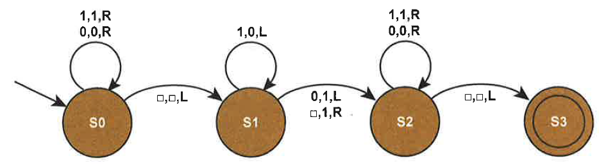

... |  |  | 1 | 1 |  |  | ...
S0

... |  |  | 1 | 1 |  |  | ...
... |  |  |  |  |  |  | ...
... |  |  |  |  |  |  | ...
... |  |  |  |  |  |  | ...
... |  |  |  |  |  |  | ...
... |  |  |  |  |  |  | ...
... |  |  |  |  |  |  | ...
... |  |  |  |  |  |  | ...
... |  |  |  |  |  |  | ...

Transition functions
The transition rules for any Turing machine can be expressed as a “Transition function ” (delta). The rules are written in the form
- (Current state, Input symbol) = (Next state, Output symbol, Movement).
Thus the rule:
- (S1, 0) = (S2, 1, L)
Means:
“If the machine is currently in state S1 AND the input symbol read from the tape is 0, THEN write a 1 to the tape AND move left AND change state to S2”

Question:
Looking at the state transition diagram above, write the transition rules for the inputs 0, 1 and when the machine is in state S0

Answer: (please complete)
δ (S0, 0) = (S0, 0, R)

Question:
Explain what a Turing machine is

Question:
Explain what a Universal Turing machine is

Question
A Turing machine’s transition function is defined as:
δ (S1, 0) = (S1, 0, R)
δ (S1, 1) = (S1, 1, R)
δ (S1, ) = (S2, 0, L)
S1 is the start state and S2 is the accepting state. The read/write head is positioned under the left-most 1.

Trace the computation of the Turing machines:
... | 1 | 1 | 0 | 1 | 0 | ... | Current state? S1
... | 1 | 1 | 0 | 1 | 0 | ... | Current state?
... | 1 | 1 | 0 | 1 | 0 | ... | Current state?:
... | 1 | 1 | 0 | 1 | 0 | ... | Current state?
... | 1 | 1 | 0 | 1 | 0 | ... | Current state?
... | 1 | 1 | 0 | 1 | 0 | ... | Current state?
... | 1 | 1 | 0 | 1 | 0 | ... | Current state? S2

Fill in the gaps
The initial state of the Turing machine is called the .....................................
A ...............................................is a theoretical model of computation
The ......................................stops the Turing machine
The .........................................................is a visual representation of the transition function of a Turing machine
State transition diagram / Start state / Halting state
Turing machine / Read/Write head / Transition function

