Graph
A graph is a mathematical structure that models the relationship between pairs of objects.

A simple (weighted) graph
- The circle is called a Vertices or node
- The line that connects them is called an edge or an arc
- The arcs have no arrow (bidirectional) so graph is called an undirected graph
- Because the only edge is labelled (with a distance) the graph is called a weighted graph

Question

Using the descriptions above, describe the following graph:
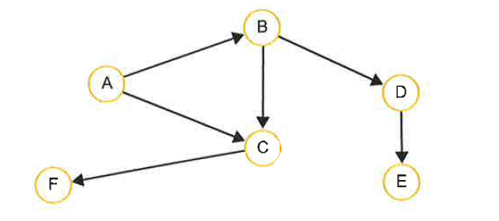

This is a ........................... , .............................. graph

Uses of graphs
- Model complex real-life problems e.g
  - Human networks
  - Transport networks (roads/rail and rail fares)
  - The internet
  - Computer networks

Implementing a graph (2 implmentations – adjacency matrix vs adjacency list )

The adjacency matrix
A 2D array can be used to store information about a directed or undirected graph. Each of the rows and columns represents a node and a value stored in the cell at the intersection of for i column j indicated that there is an edge connecting node i and node j.
 | A | B | C | D | E | F
A |  | 5 | 4
B |  |  | 6 | 3
C |  |  |  |  |  | 8
D |  |  |  |  | 2
E
F

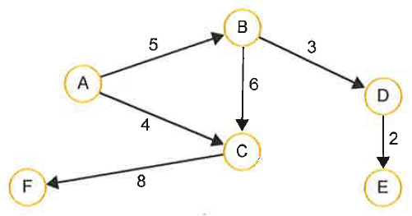

In the case of an undirected graph, the adjacency matrix will be symmetric, with the same entry in row 0 column 1 as in row 1 column 0. For example, an unweighted graph may be represented with 1s instead of weights, in the relevant cells.

Question

Draw an adjacency matrix to represent the weighted graph below:
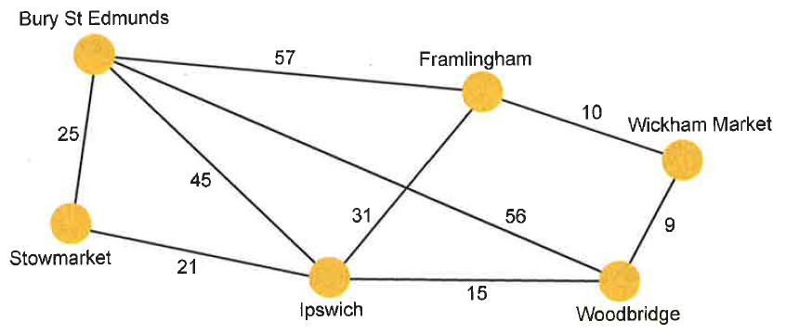
 | Bury St Edmunds | Framlingham | Wickham Market | Wood-bridge | Ipswich | Stow-market
Bury St Edmunds
Framlingham
Wickham Market
Woodbridge
Ipswich
Stowmarket

Advantages: Convenient to work with / quick to add an arc / quick to test for presence of arc
Disadvantages: A sparse graph with many nodes but not many arcs will leave most of the cells empty. Large the graph the more memory space will be wasted.

The adjacency list

A list of all the nodes is created and each node points to a list of all the adjacent nodes to which it is directly linked. The adjacent list can be implemented as a list of dictionaries, with the key in each dictionary being the node and the value, the edge weight.

The graph in the (adjacency matrix) above would be represented as follows:

A |  | → | {B:5, C:4}
B |  | → | {C:6, D:3}
C |  | → | {F:8}
D |  | → | {E:2}
E |  | → | {}
F |  | → | {}

Advantages: more space efficient. Uses much less memory to represent a sparsely connected graph.

The unweighted version of the same graph would be represented as below (notice dictionary data is not required as there a no edge weights)

A |  | → | [B,C]
B |  | → | [C,D]
C |  | → | [F]
D |  | → | [E]
E |  | → | []
F |  | → | []

Advantage: uses much less memory

Question

Draw an adjacency list to represent the unweighted graph show below (but assuming this time that it is undirected)

Question
The figure below shows an adjacency matrix representation of a directed graph (digraph)

 |  | To
 |  | A | B | C | D | E
From | A | 0 | 5 | 3 | 10 | 0
 | B | 0 | 0 | 1 | 8 | 0
 | C | 0 | 0 | 0 | 7 | 6
 | D | 0 | 0 | 0 | 0 | 4
 | E | 0 | 0 | 0 | 0 | 0

Question: Draw a diagram of the directed graph, showing edge weights

Question: Draw an adjacency list representing this graph

Question: Give one advantage of using an adjacency matrix to represent a graph and one advantage of using an adjacency list. Explain the circumstances in which each is more appropriate.

Question: Graph algorithms are used with GPS nav systems, social networking, gaming etc. Describe two practical applications of graphs. (help: Google“practical applications of graph algorithms”)

