Sound – Green pen exercise

What is sampling?

Which of the following samples will most likely have the best audio quality?
- 2,000
- 30,000
- 44,100
- 11,400
What is Bit depth?

Which of the following bit depths will most likely have the best audio quality?
- 2
- 24
- 8
- 16
Label the graphs below with the following labels: “Louder”, “Quieter”, Higher pitch” and “Lower pitch”

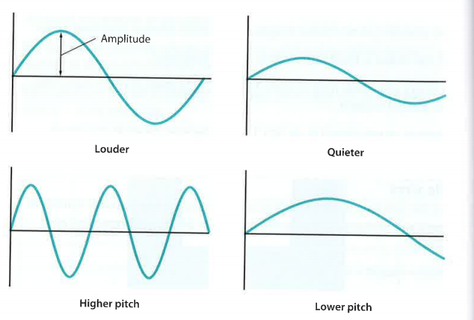
Name 3 examples of an analogue signal | Name 3 examples of a digital signals

What are the 4 things the size of a digital audio sound file depends on?

Calculate the file size of a stereo recording of three minutes duration with a sample rate of 44,100 and bit depth of 24 bits? Provide the answer in Megabytes
Number of samples per second =
Bit depth =
Duration =
Number of channels =
The size of the file is found from the following formula:
File size in bits = sample rate * bit depth * duration in sec * no. Of channels

What is Fidelity?

EXTENSION: Please answer the following questions on lined paper
